**Web Lesson Project**

Lesson Name: **Web Technologies**

Teacher: **CAN YÜZKOLLAR**

Subject: **Project**

Name: **Ammar**

Last name: **AJAM**

Student number: **G231210554**

Group: **A**

Github: <https://github.com/DarkAndLighto/WebTechnologyProject>

Host site: <https://weblessonproject.000webhostapp.com/>

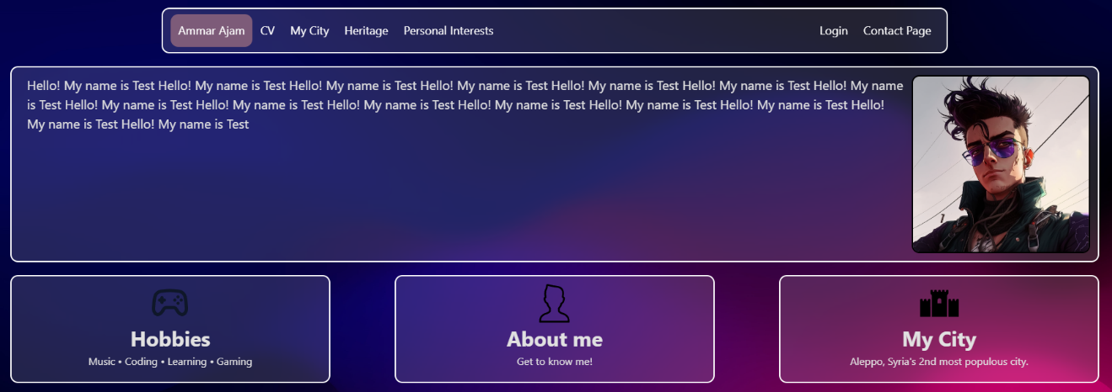

|  |
| --- |
| ***ABOUT ME PAGE***  This page is the main page of the website, and its primary purpose is to serve as an introductory, and a guide to the rest of the website. |